Analysis of SOLWEIG v2022a (UMEP QGIS plugin)
Weekly Progress Report — Weeks 5 & 6 (QGIS Plugin Development)
Student: San | QGIS 4.0.3-Norrköping | GA Summer 2026

Week 5 — QGIS Plugin Skeleton (hello world)
Goal: Build a loadable QGIS plugin using the same contract as SOLWEIG/UMEP.
- Created hello_qgis_plugin with metadata.txt, __init__.py (classFactory), hello_plugin.py (initGui/unload/run).
- Plugin appears in Plugins menu; dialog opens; 'Count layers' calls QgsProject API.
- Installed to QGIS 4 profile: ...\QGIS\QGIS4\profiles\default\python\plugins\
- Lesson: QGIS 3 and QGIS 4 use separate plugin folders — must install to QGIS4 for 4.0.3.
Week 5 — Plugin structure
hello_qgis_plugin/
metadata.txt
__init__.py → classFactory(iface)
hello_plugin.py → HelloPlugin + HelloDialog
Week 5 — Screenshots
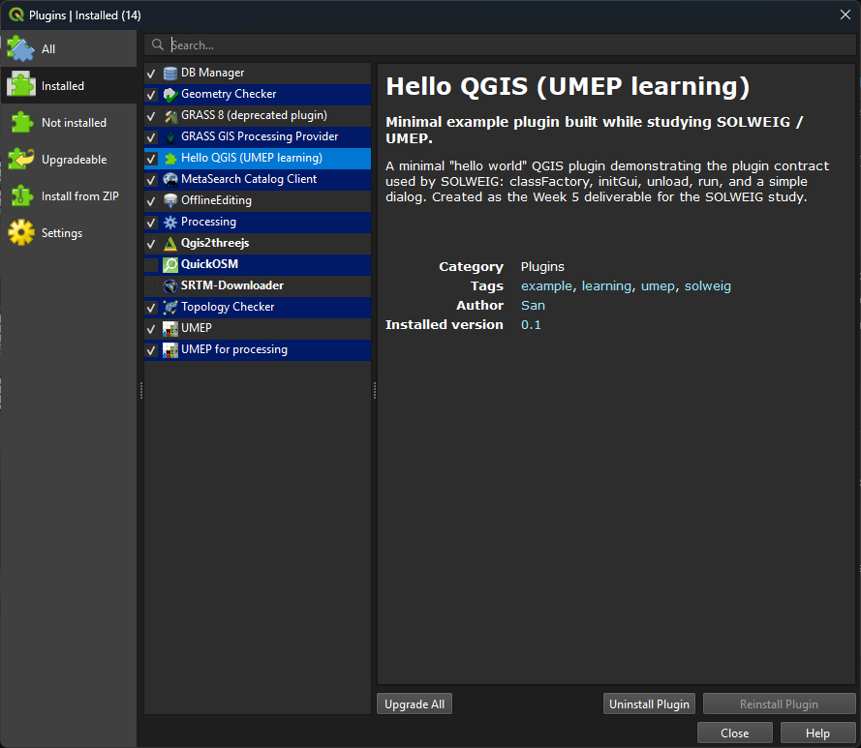
Fig 5.1 — Plugin enabled in Manage and Install Plugins
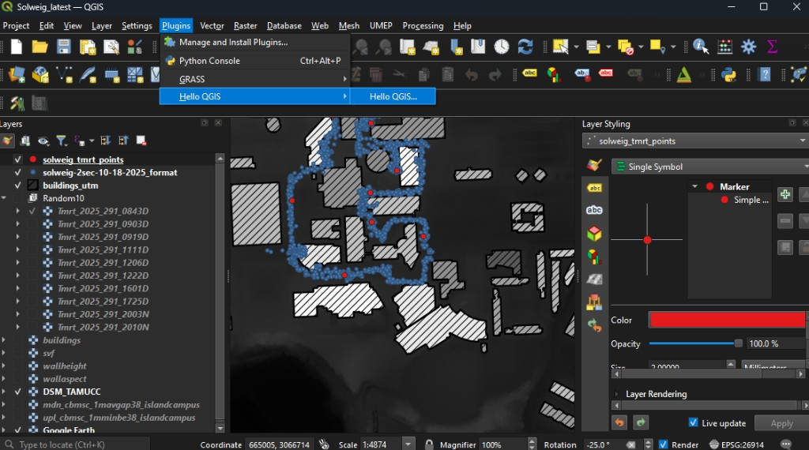
Fig 5.2 — Plugins → Hello QGIS menu entry
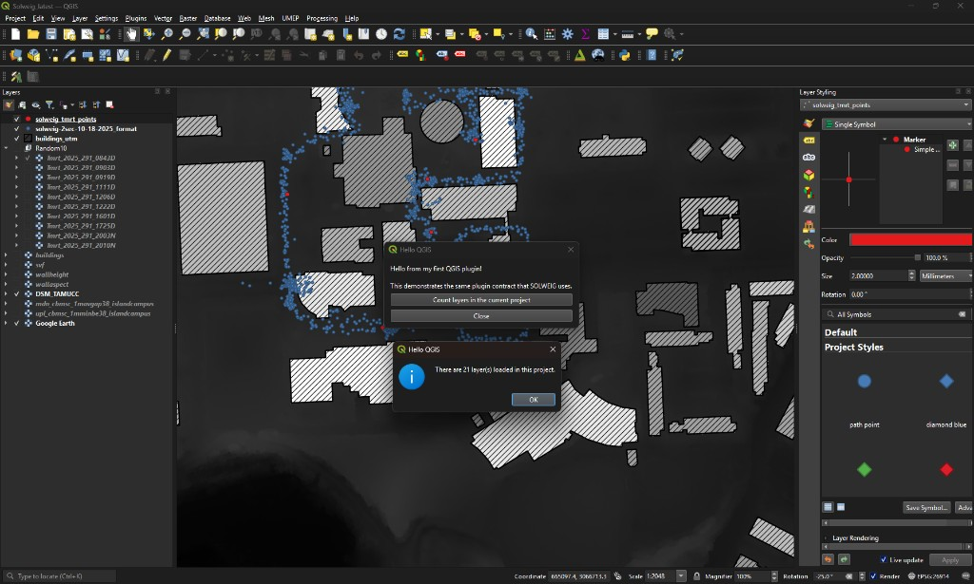
Fig 5.3 — Dialog on Solweig_latest project; layer count = 21
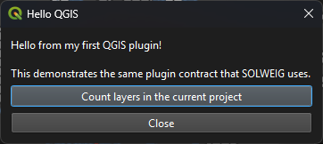
Fig 5.4 — Main Hello QGIS dialog

Week 6 — Input Handling, UI & Layer Selection
Goal: Extend the plugin to read GIS inputs the way SOLWEIG does — layer pickers, GDAL → NumPy, validation, parameters.
Plugin version: 0.2
Week 6 — Tasks completed
- QgsMapLayerComboBox: primary raster, second raster (match check), point layer (POI).
- read_raster_summary(): GDAL ReadAsArray, GetGeoTransform → scale, NoData handling, lat/lon via osr.
- rasters_match(): shape + pixel-size validation (same rule as SOLWEIG).
- Parameter spinboxes: absK=0.70, absL=0.95, albedo=0.20.
- Summary panel + success/error dialogs.
Week 6 — Test run (Solweig_latest)
Primary raster | buildings
Shape | 1346 rows × 1445 cols
Pixel size / scale | 1.0000 m / 1.0000
CRS | EPSG:26914
Corner lat/lon | 27.70661, -97.33157 (WGS84)
Match check | Extent and resolution match
Point layer | solweig_tmrt_points (10 features)
Parameters | absK=0.70, absL=0.95, albedo_w=0.20

Week 6 — Screenshots
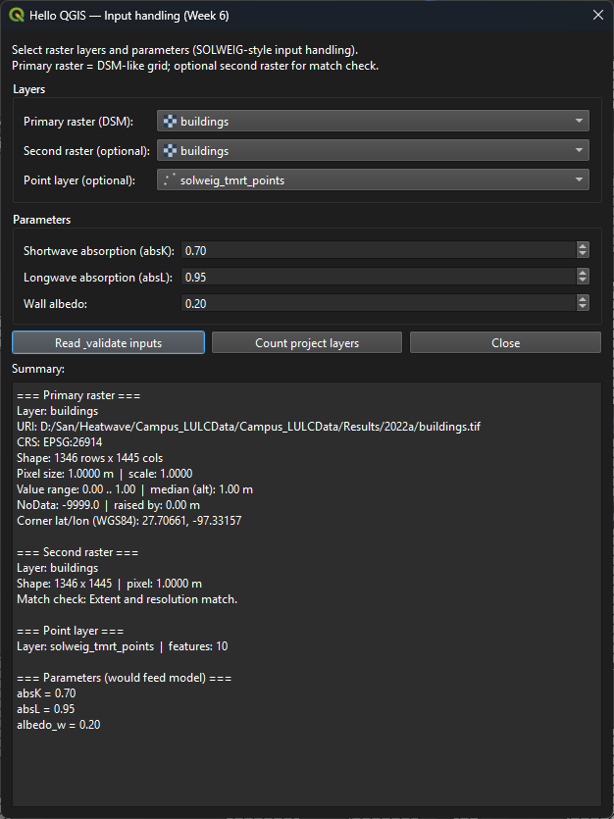
Fig 6.1 — Read & validate: full summary panel with raster metadata
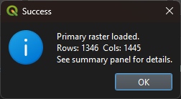
Fig 6.2 — Success: primary raster loaded (1346 × 1445)
Week 6 — Mapping to SOLWEIG
SOLWEIG | Our plugin (Week 6)
QgsMapLayerComboBox for DSM, DEM, walls… | 2 raster + 1 point combo
gdal.Open + ReadAsArray in start_progress | read_raster_summary()
Extent/resolution abort on mismatch | rasters_match() + warning
Parameters in .ui file | Spinboxes in dialog (defaults from SOLWEIG)

Next (Week 7): QThread worker + progress bar + write output GeoTIFF.

